# Objective 1- To identify the number of companies existing in SEC database

Select count(distinct(company_name)) as Total_company

From [bigquery-public-data:sec_quarterly_financials.quick_summary]

# Answer= 14851

# Objective 2- Select all companies that used measure_tag as goodwill

SELECT *

FROM [bigquery-public-data:sec_quarterly_financials.quick_summary]

WHERE measure_tag="Goodwill"

#ANSWER 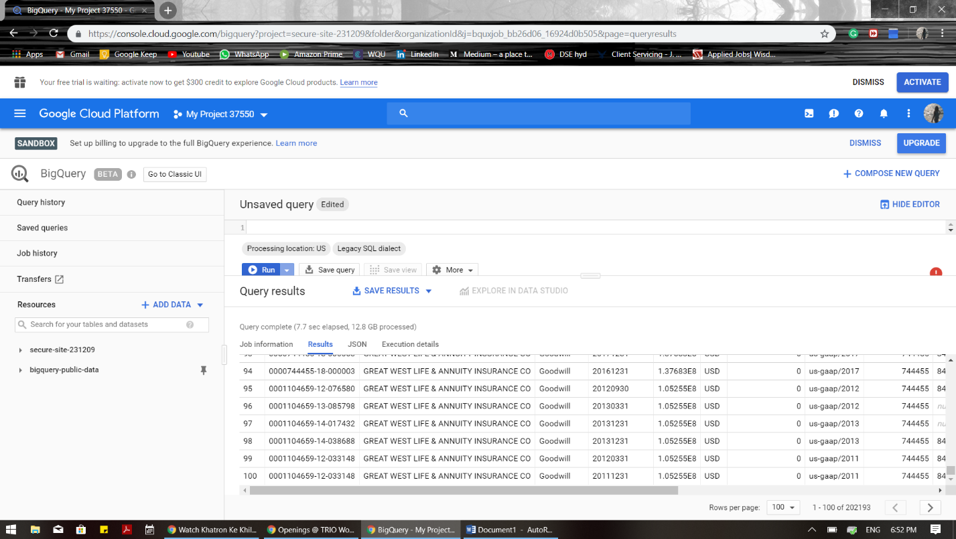

#Objective 3

SELECT *

FROM [bigquery-public-data:sec_quarterly_financials.quick_summary]

WHERE form="10-Q"

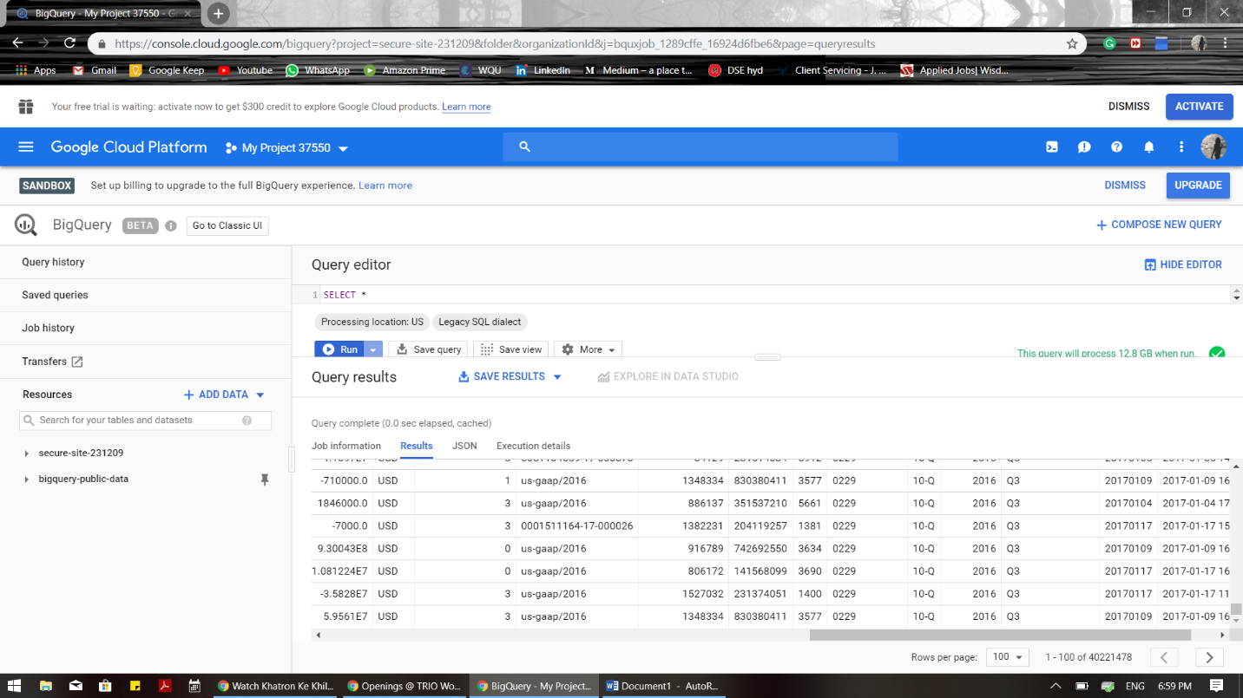#ANSWER

#Objective 4- Finding top 5 Companies with highest 'value' considered as Performance according to their Goodwill.

SELECT company_name,measure_tag,max(value) as Performance

FROM [bigquery-public-data:sec_quarterly_financials.quick_summary]

WHERE measure_tag="Goodwill"

GROUP BY company_name,measure_tag

LIMIT 5

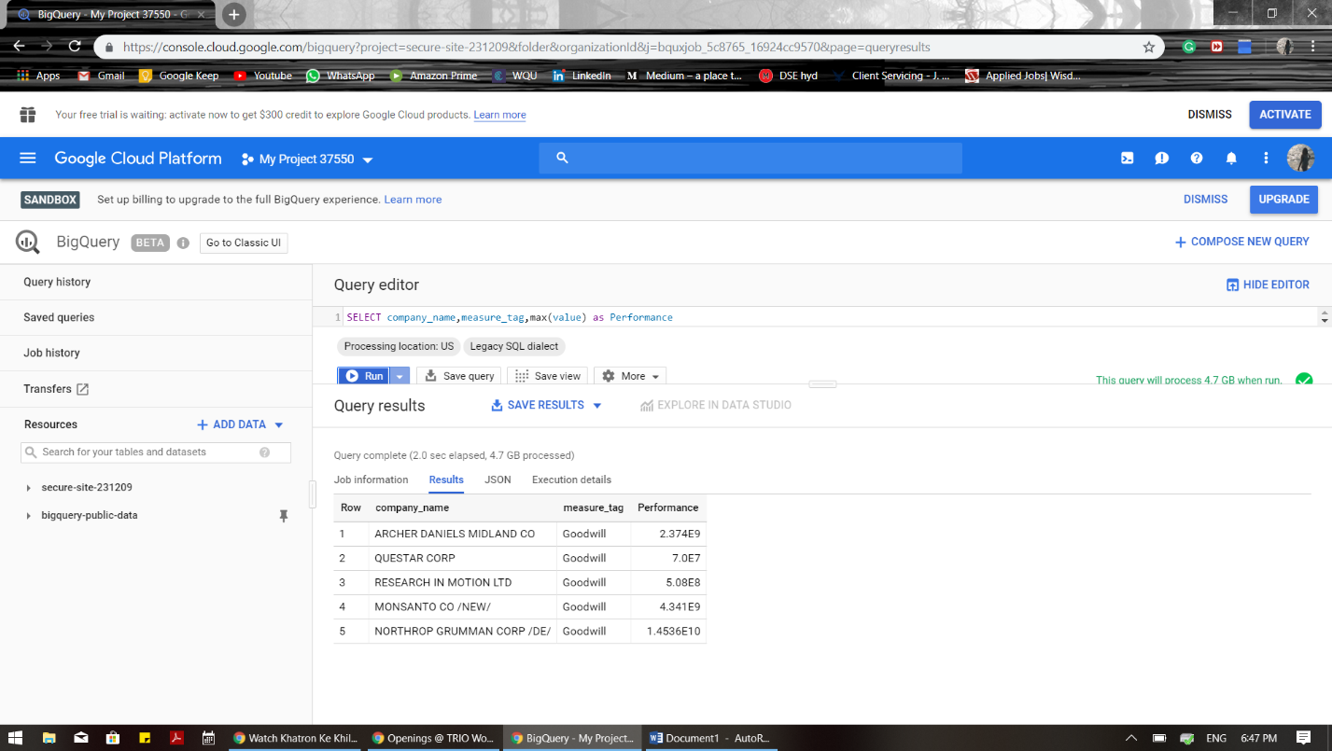#ANSWER

#Objective 5- find the last date of data filed by each company

SELECT company_name,max(date_filed) as Date_filed

FROM [bigquery-public-data:sec_quarterly_financials.quick_summary]

GROUP BY company_name

#Answer : 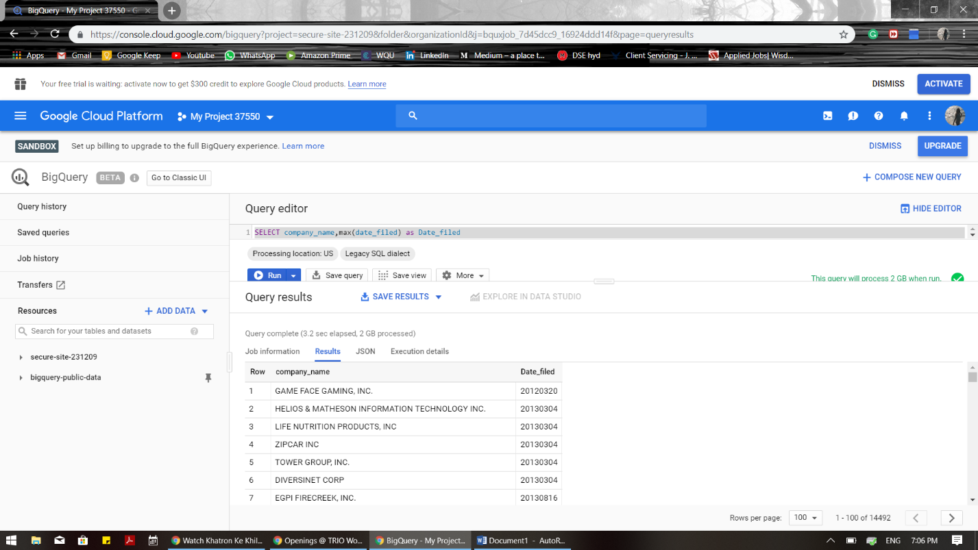

#Objective- 6 Number of customers that belong to various countries having minimum number of customers per country as 3.

SELECT COUNT

(CustomerID), Country

FROM Customers

GROUP BY Country

HAVING COUNT(CustomerID) > 3

ORDER BY COUNT(CustomerID) DESC;

# ANSWER:

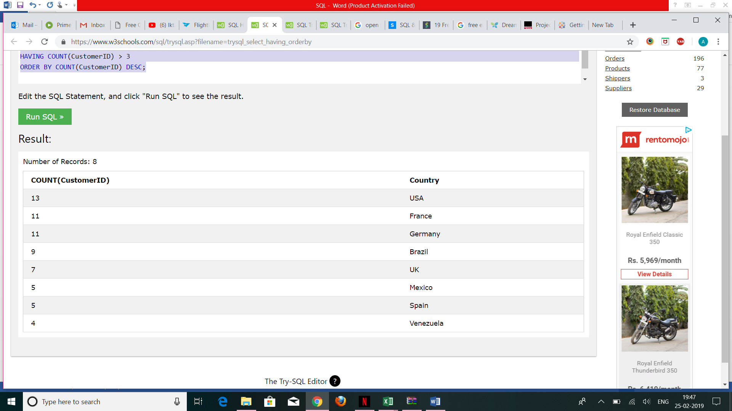

#Objective 7- Combining both customers and suppliers data of Germany and its cities.

SELECT City, Country FROM Customers

WHERE Country='Germany'

UNION

SELECT City, Country FROM Suppliers

WHERE Country='Germany'

ORDER BY City;

#Answer:

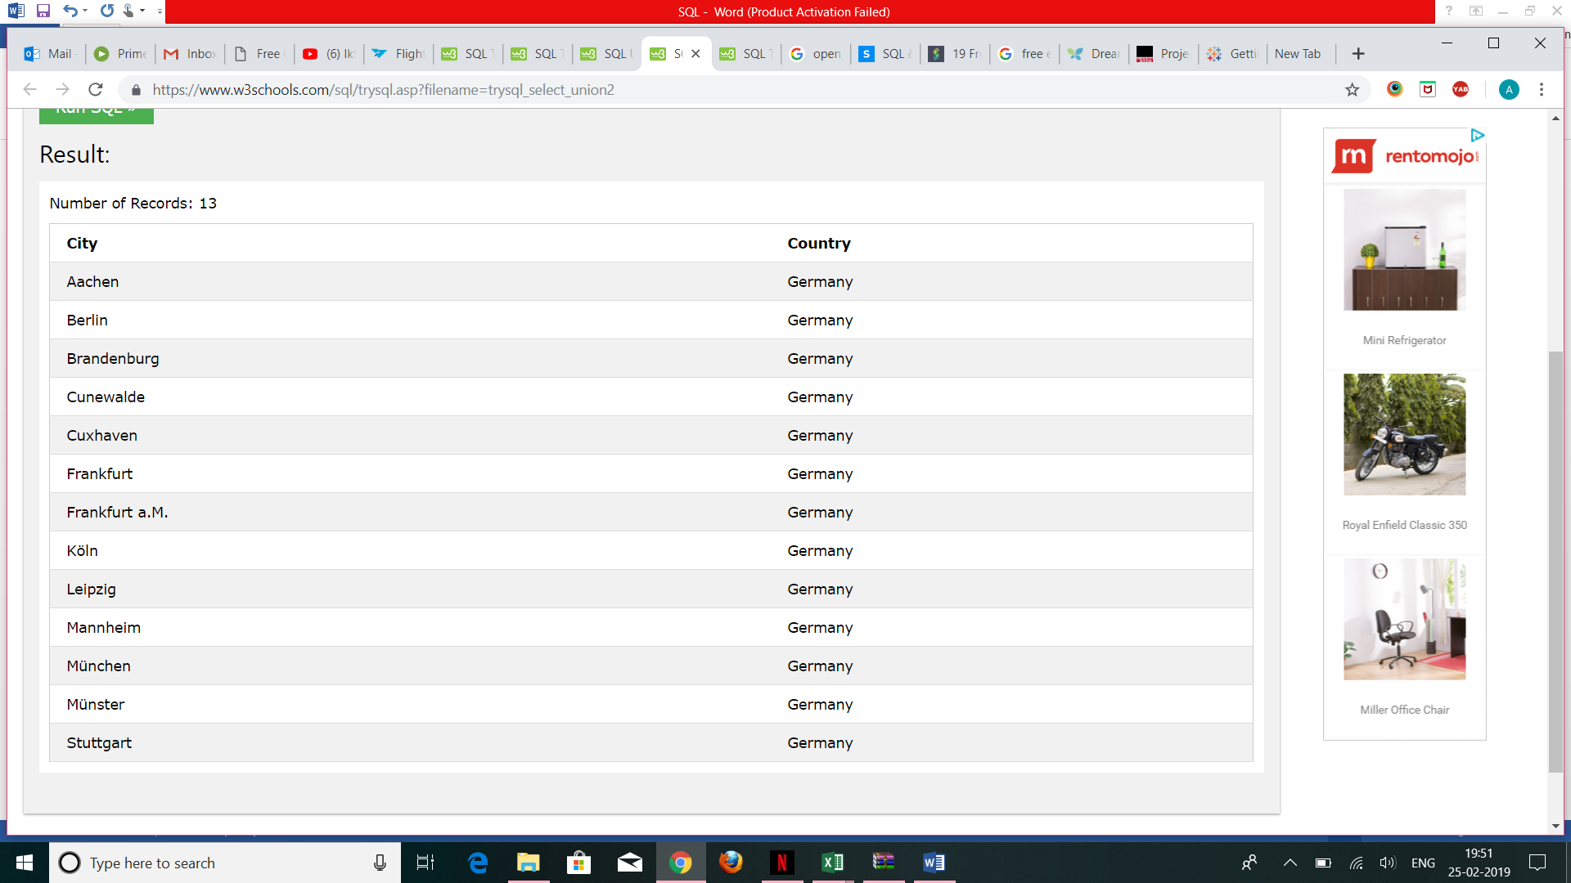

#Objective 8 to find the name of the supplier offering price 22 given product name and supplier ID.

SELECT SupplierName

FROM Suppliers

WHERE EXISTS (SELECT ProductName FROM Products WHERE SupplierId = Suppliers.supplierId AND Price = 22);

#Answer :

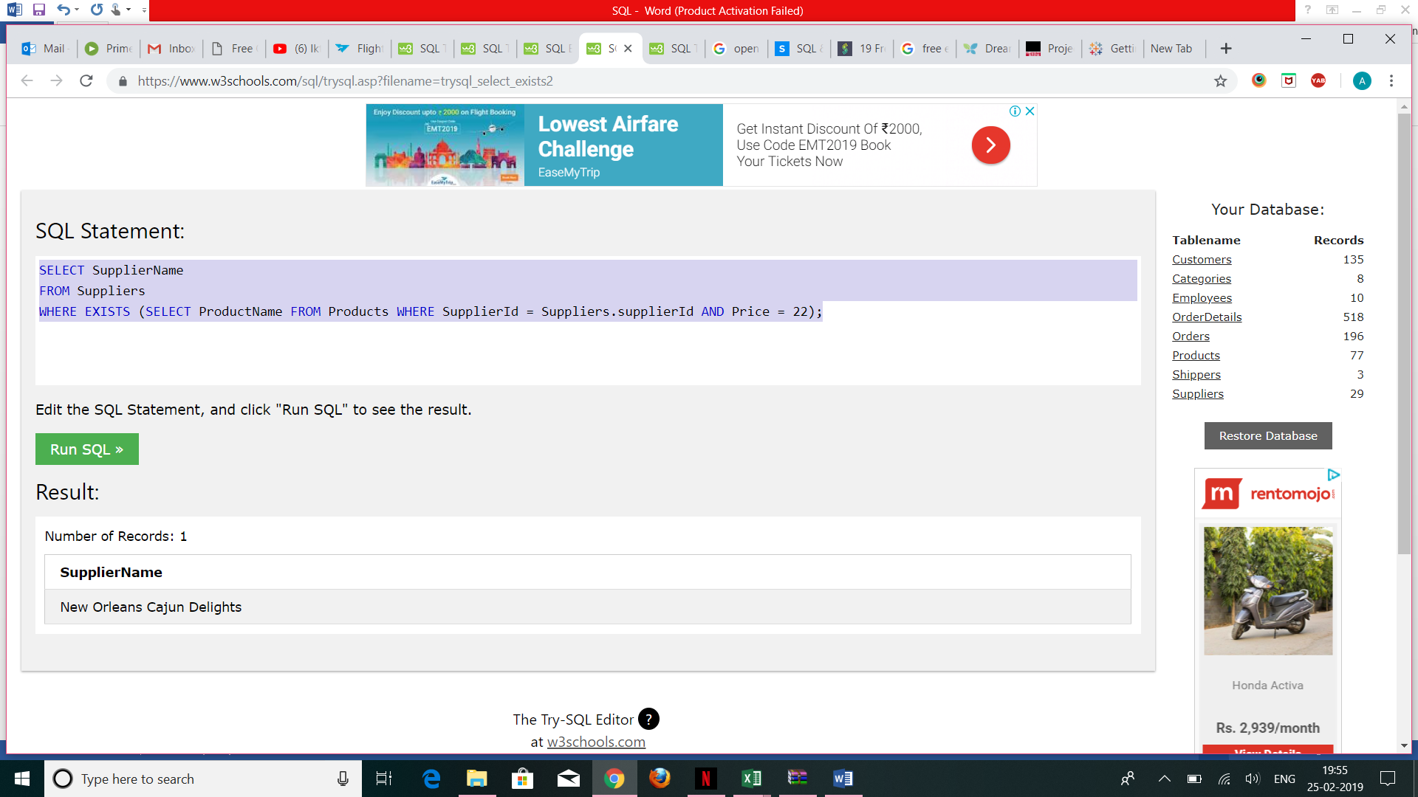

#Objective 9 Left Joined Shippers table on Number of orders to find the number of orders per shipper.

SELECT Shippers.ShipperName,COUNT(Orders.OrderID) AS NumberOfOrders FROM Orders

LEFT JOIN Shippers ON Orders.ShipperID = Shippers.ShipperID

GROUP BY ShipperName;

#Answer:

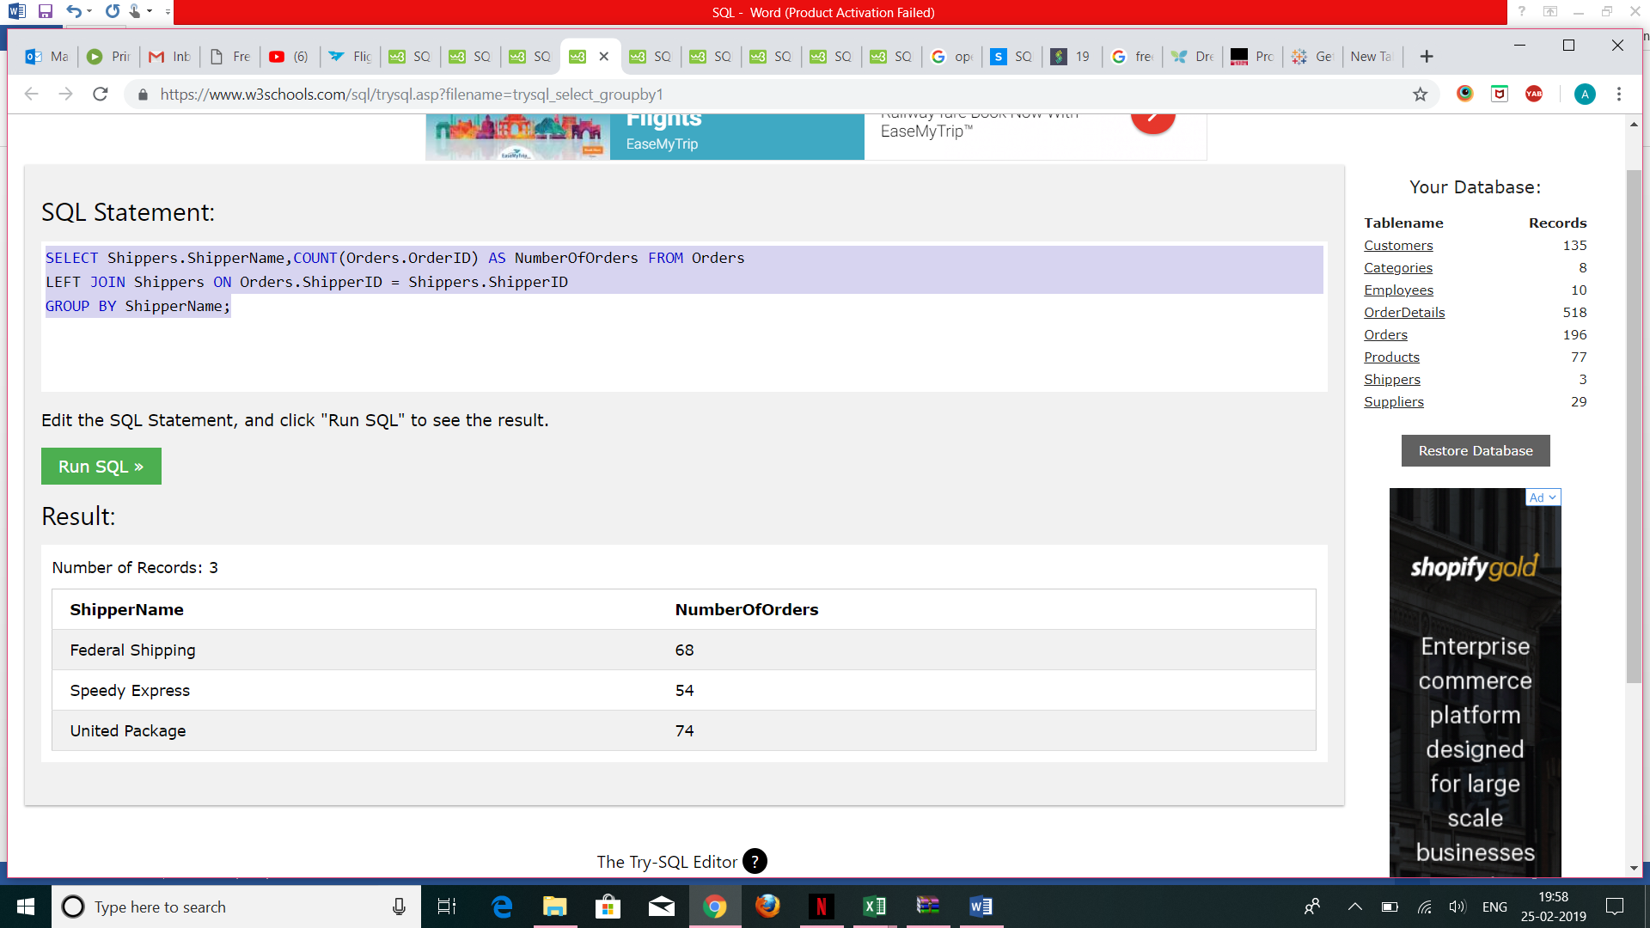

#Objective 10 To find complete data having price between 10 and 20. Also having category ID >3.

SELECT * FROM Products

WHERE (Price BETWEEN 10 AND 20)

AND NOT CategoryID IN (1,2,3);

#Answer:

